**College-Website**

**Name: Rahul Kr. Thakur**

**Type of Project: Web Application**

**Languages used: HTML5, CSS3, Bootstrap5, JavaScript, jquery**

**Date of Submission: 27/05/2024**

**Summary of "College-Website" Web Application**

The **"College-Website"** web application is a responsive and visually appealing platform designed to keep students and staff informed about various events and activities happening at the college. Developed using HTML, CSS, and Bootstrap, query the application offers a comprehensive user experience with several key features:

* **Navigation Bar (Navbar):** A well-structured navbar that allows easy access to different sections of the website.
* **Carousel and Slider:** Dynamic carousels and sliders to highlight upcoming events and activities prominently on the homepage.
* **Events Category:** A dedicated section to categorize and display different types of events, making it easy for users to find events of interest.
* **About Us Section:** Provides detailed information about the college and the purpose of the application.
* **Contact Us Section:** Enables users to get in touch with event organizers or the college administration for any inquiries or support.
* **Footer Section:** Contains additional links, social media icons, and other relevant information.
* **Login and Registration Pages:** Secure login and registration pages for users to create accounts and access personalized features.

**University.html:**

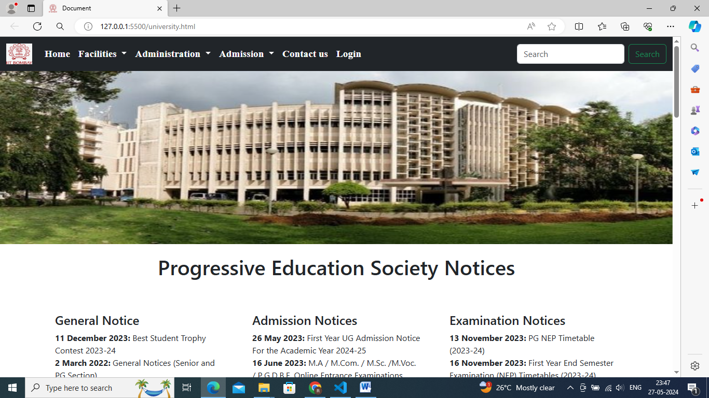

Department of IIT Bombay

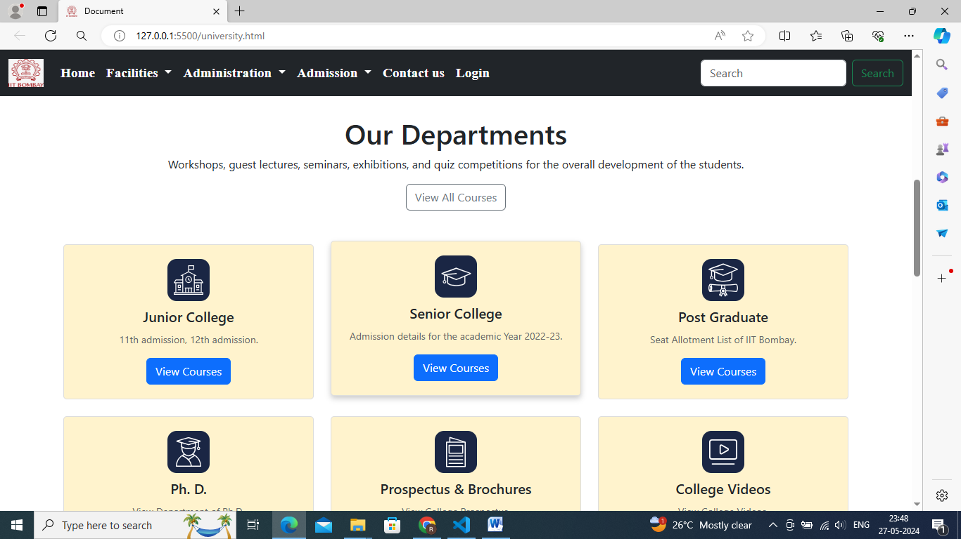

Placement:

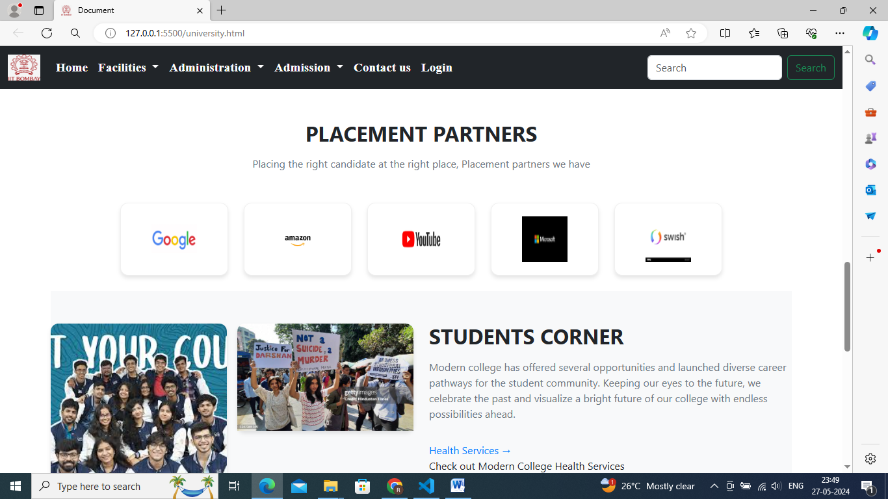

Navbar:

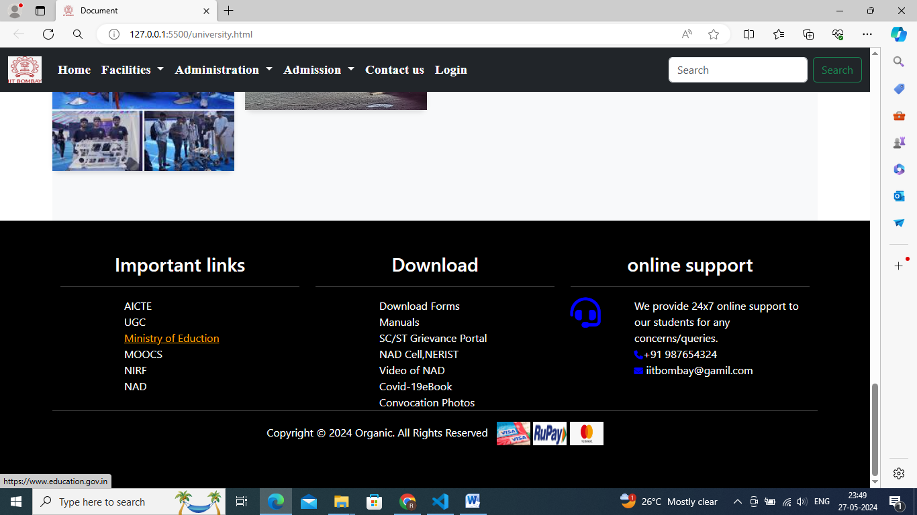

IIT Bombay Research Projects:

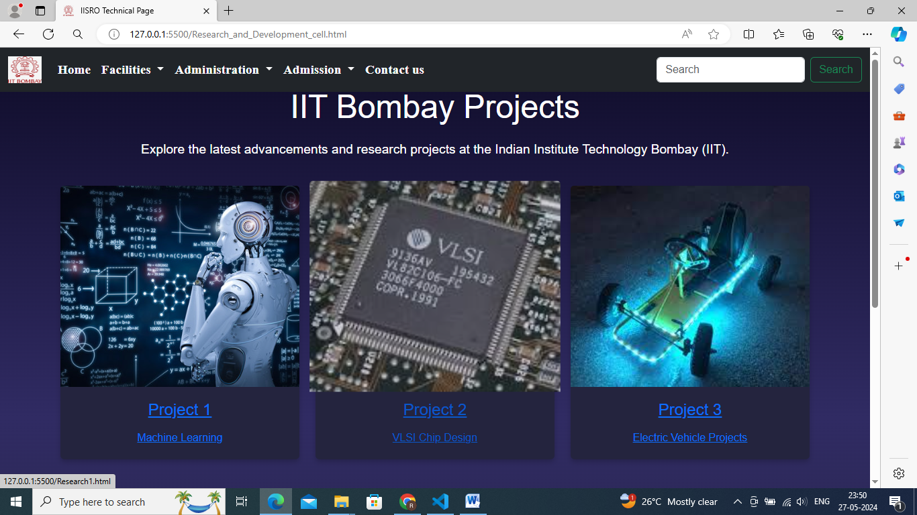

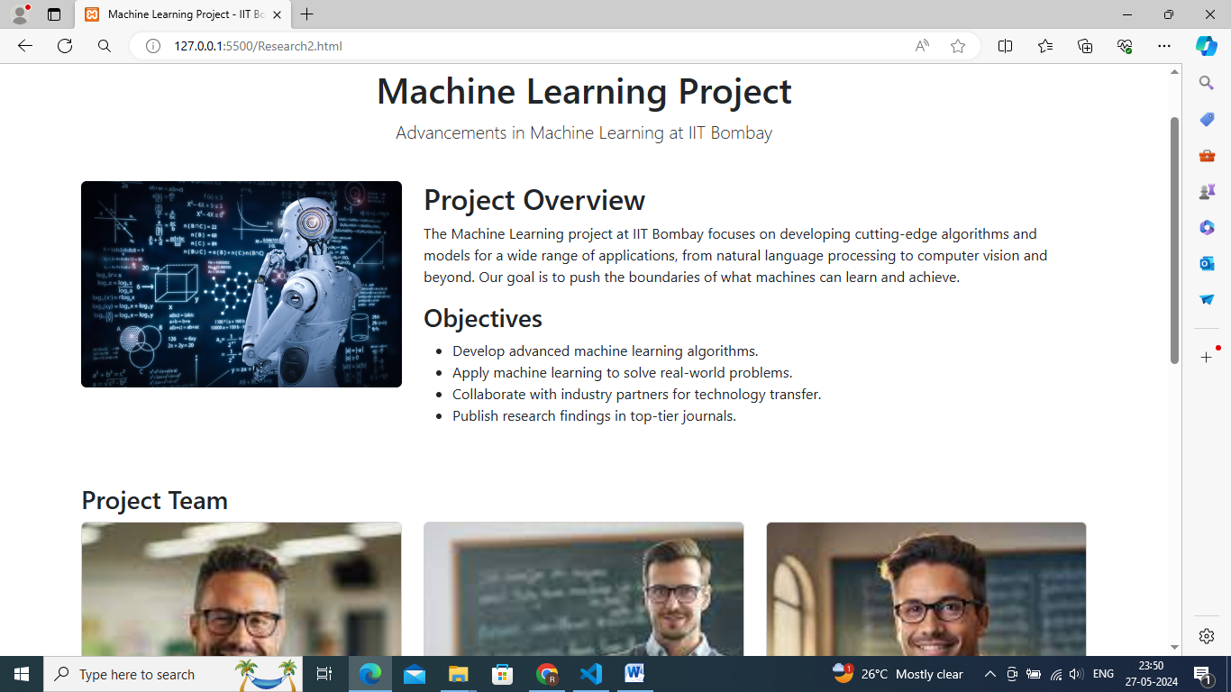

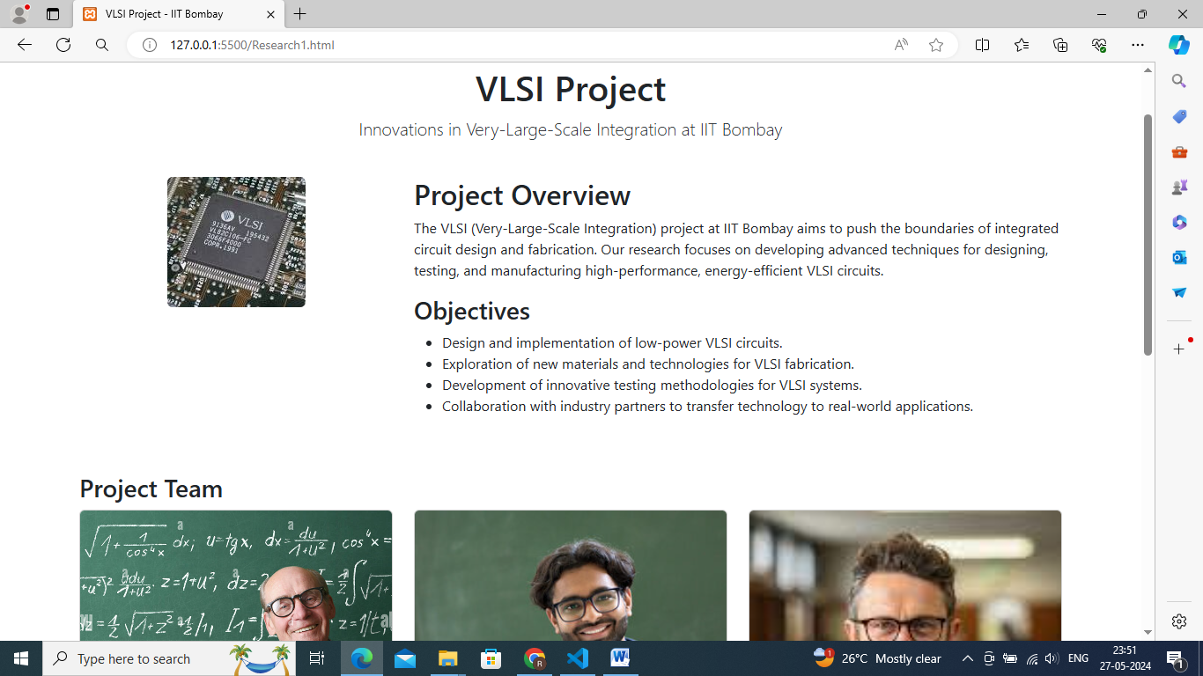

Navbar

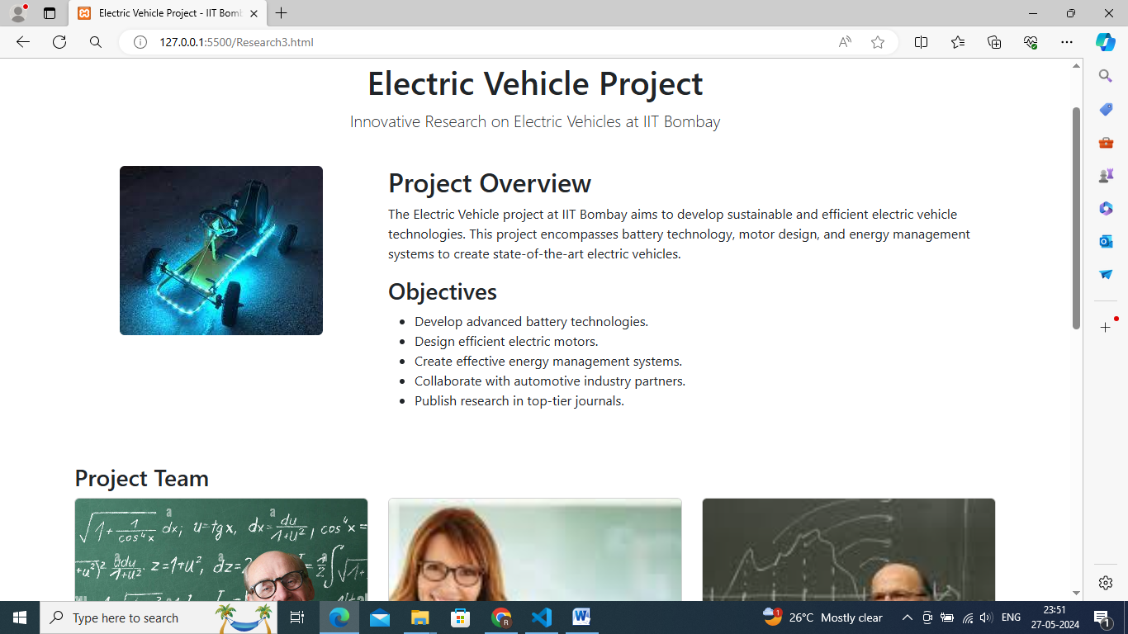

Faculties:

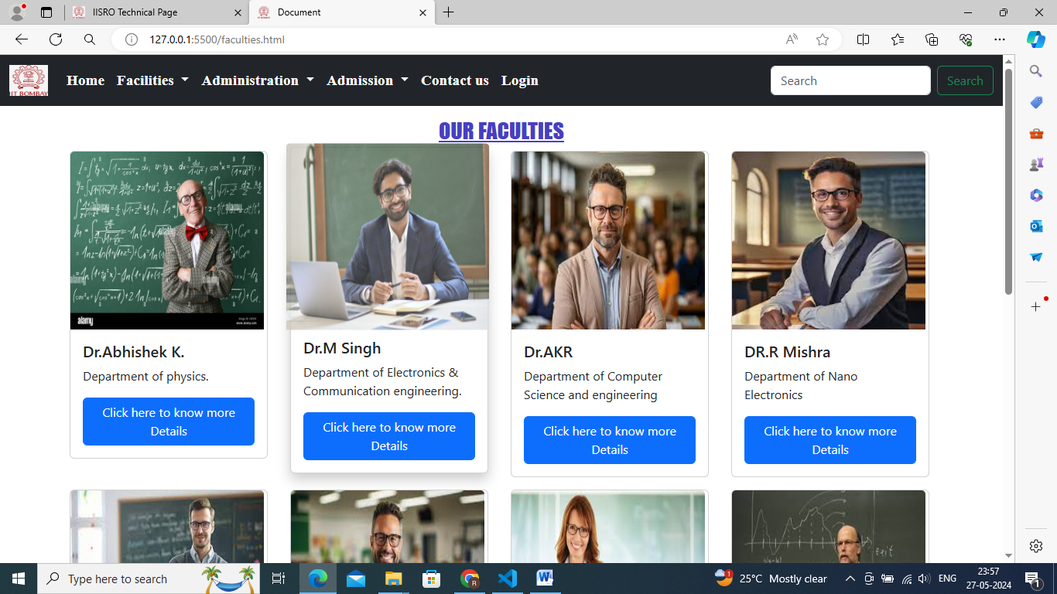

About us

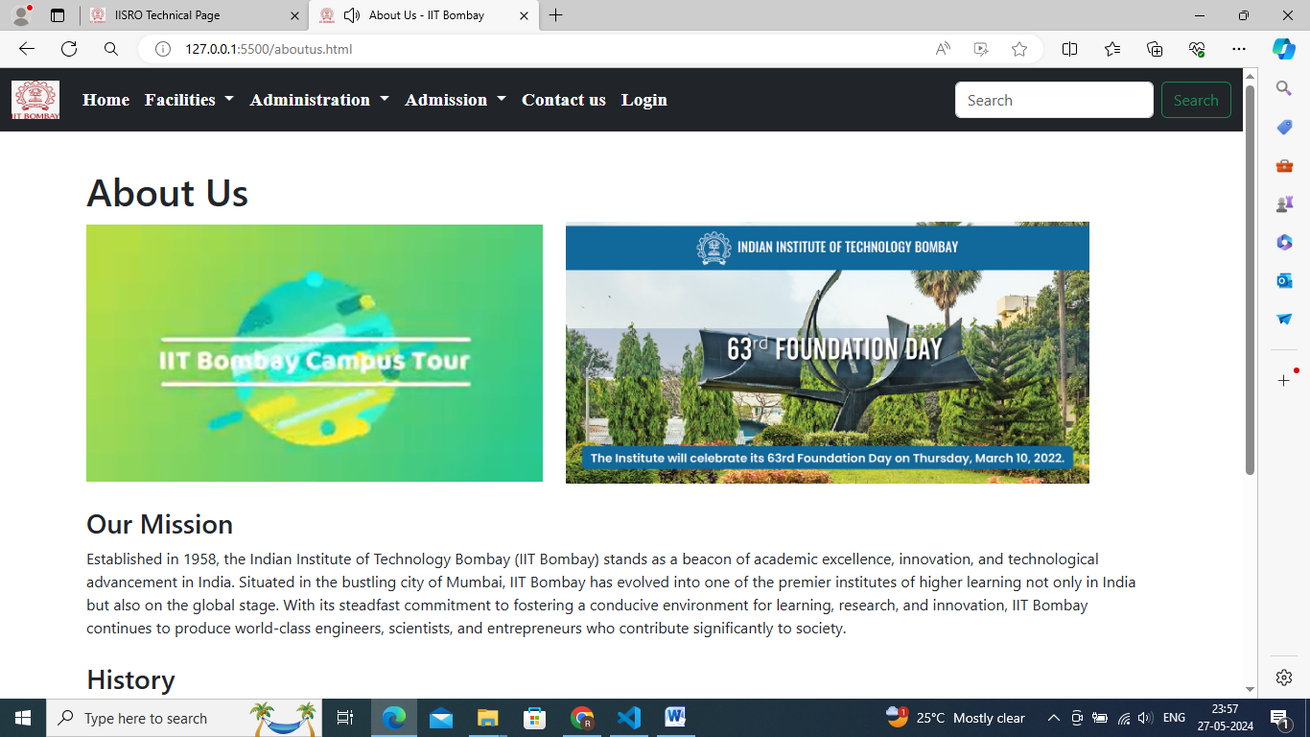

Admission structure

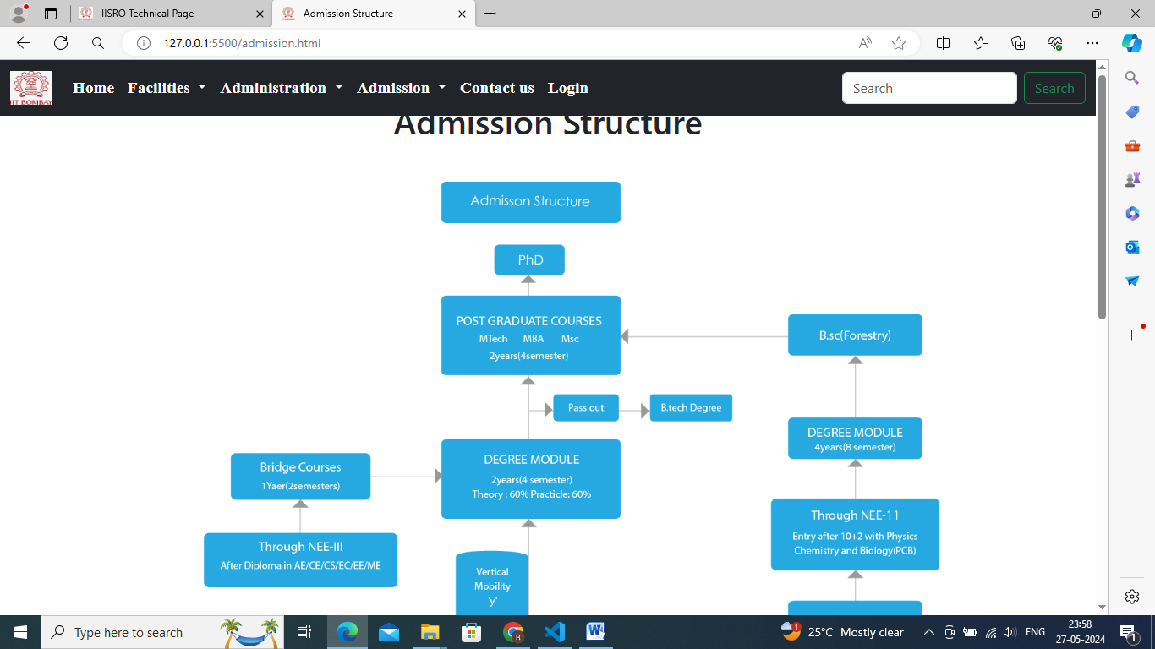

Reach us:

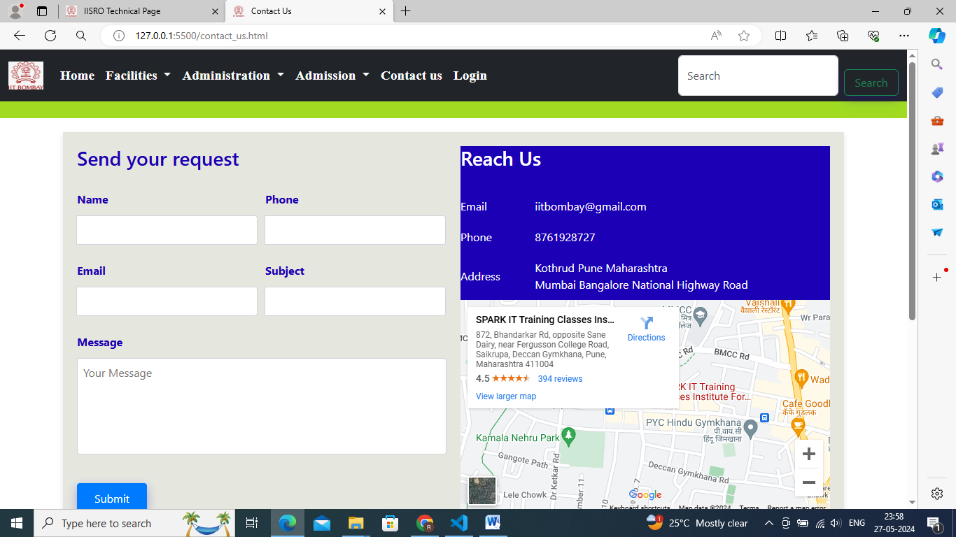

Sign up page:

